## Windows in Idle

Idle has several parts you may choose to display, each with its own window. Depending on the configuration, Idle can start up showing either of two windows, an Edit Window or a Python Shell Window. You are likely to first see an Edit window, whose top left corner looks something like in Windows:

[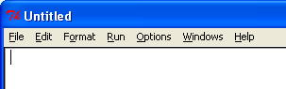](http://anh.cs.luc.edu/python/hands-on/3.1/handsonHtml/_images/IdleEditWindow.png)

If you see this Edit Window with its Run menu on top, go to the Run menu and choose PYTHON SHELL to open a Python Shell Window for now. Then you may close the Edit Window.

Either initially, or after explicitly opening it, you should now see the Python Shell window, with a menu like the following, though the text may be slightly different:

[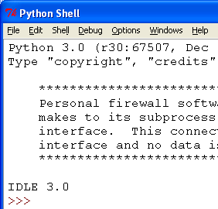](http://anh.cs.luc.edu/python/hands-on/3.1/handsonHtml/_images/IdleShellWindow.png)

Look at the Python Shell. ...

In the Shell the last line should look like

>>>

The >>> is the prompt, telling you Idle is waiting for you to type something. Continuing on the same line enter

6+3

Be sure to end with the Enter key. After the Shell responds, you should see something like

**>>>** 6+3

9

>>>

The shell evaluates the line you entered, and prints the result. You see Python does arithmetic. At the end you see a further prompt >>> where you can enter your next line.... The result line, showing 9, that is produced by the computer, does not start with >>>.